Use-Case Realization Report (Analysis)
Logout

Issue 1.0
Revision History
Date | Issue | Description | Author
29/Jul/2011 | 1.0 | Initial Document | Koh Ming Jin

Table of Contents
1. Brief Description 4
2. Flow of Events 4
2.1 Standard Flow 4
2.2 Exception 4
3. Interaction Diagrams 4
3.1 Collaboration Diagram for System Logout 4
4. Participating Objects 5
4.1 Main Page 5
4.2 Role Main Page 5
4.3 Security Controller 5
5. Class Diagrams 5
5.1 Domain Class Diagram: View Logout 5
6. Derived Requirements 5

Use-Case Realization Report
View Logout

Brief Description
This use case enables an employee to log out of the system.

Flow of Events
The standard flow of events for this use case and any exceptions are described in the following subsections. See section 3.1 for an overview of the participating Actors and Domain Objects.

Standard Flow
The flow of events is described as follows:

- The use case starts when an employee selects the Logout option of the system.
- The employee will be log out and redirected to the Main page or the Login Page.
- The use case terminates.

Exception
- NIL

Interaction Diagrams

Collaboration Diagram for System Logout
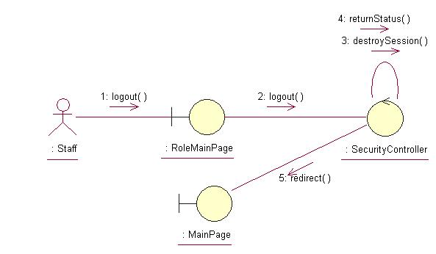

Participating Objects

Main Page
This object renders the contents to allow actors to logout into the system. All actors use this object.

Role Main Page
This object renders the contents to allow the authorized Sales staff actor to perform his or her jobs.

Security Controller
This object acts as the middleman between Main Pages and the Employee and Role objects. It will translate interactions with the view into actions to be performed by the Employee and Role objects.

Class Diagrams

Domain Class Diagram: View Logout
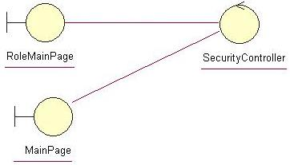

Derived Requirements
The Employee barcode scanner or PC keyboard and mouse will be used to logout into the system (if any) and view all the system responses.

